Oceans Unit Review
Vocabulary to Know
Continental slope | Continental shelf | Continental rise
Abyssal plain | Ocean trench | Estuary
Tides | Waves | Tsunamis
Surface Currents | Deep water current | Continental current
Gulf Stream Current | Solutions | Mixtures
Atom | Molecule | Compound
H2O | NaCl | Salinity
Density | ecosystem | food web
community | habitat | niche
consumers | producer | decomposers
zooplankton | phytoplankton | photosynthesis
plankton

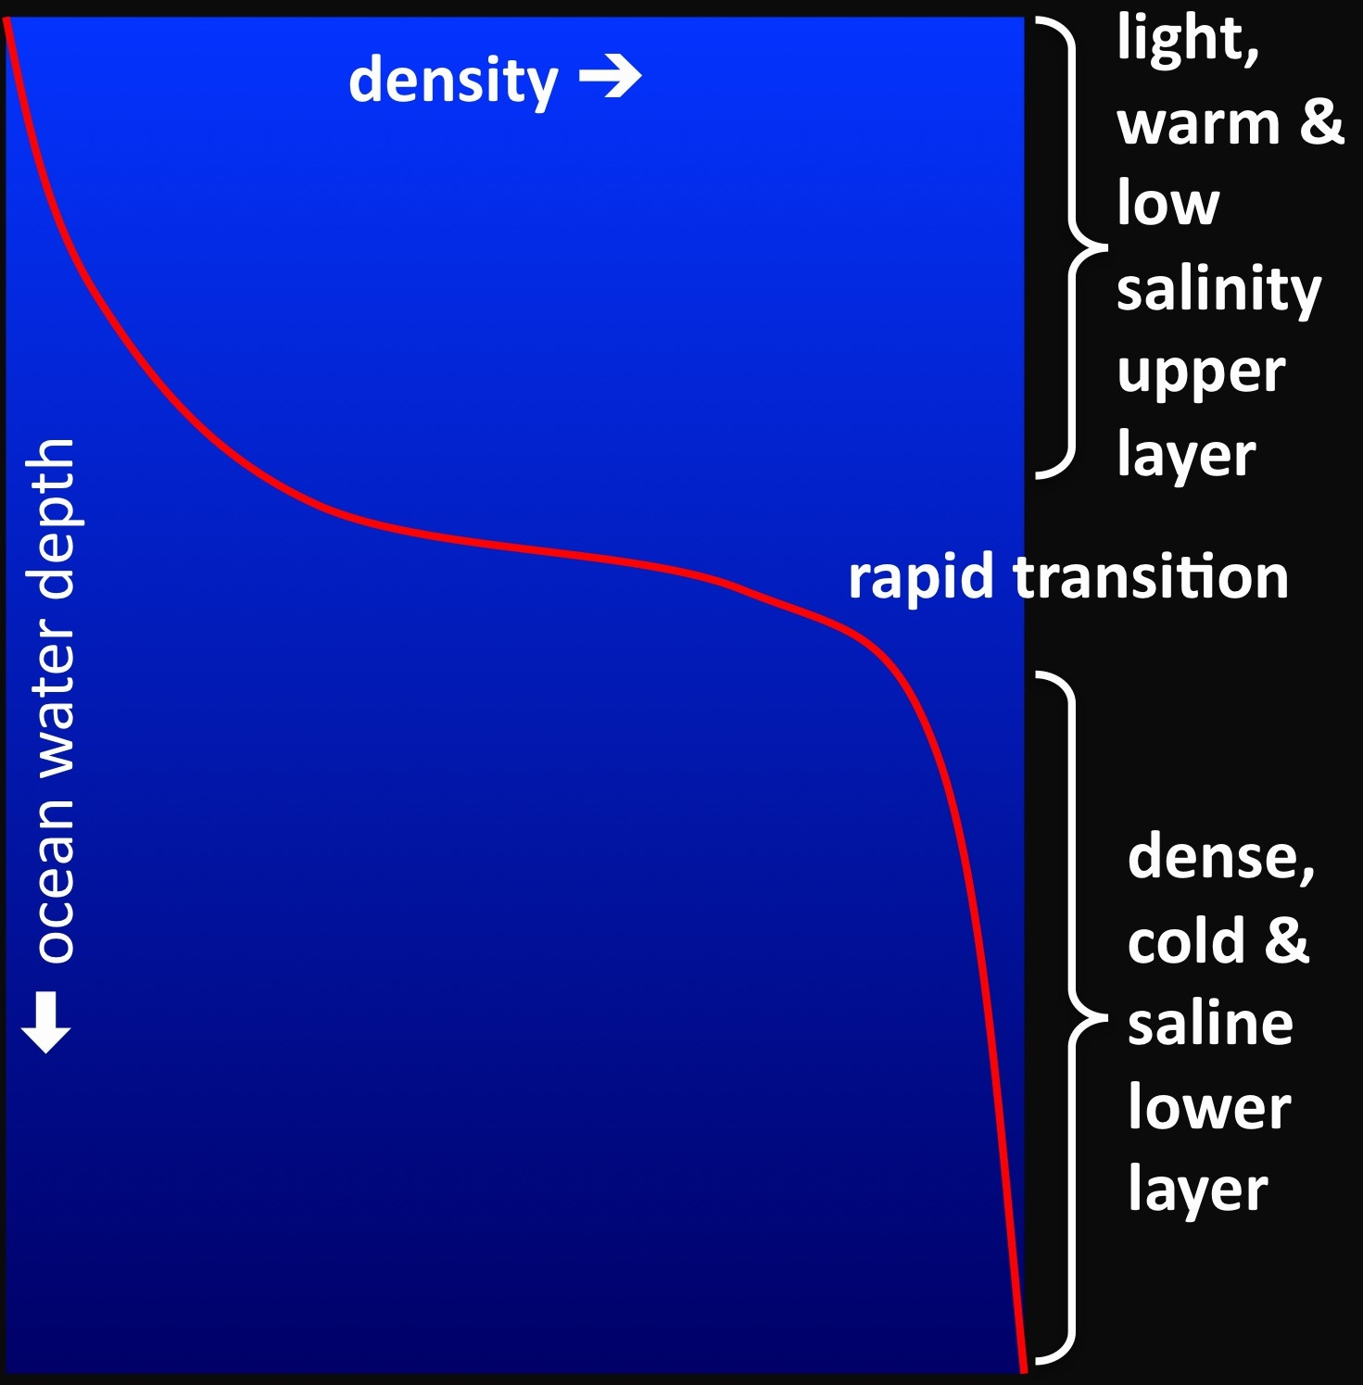
If you travel from point surface of the ocean to an ocean trench, what conclusion can you make about the depth, temperature, and marine life of the ocean?

A: As the depth of the ocean increases, the temperature decreases and the marine life decreases.
B: As the depth of the ocean decreases, the temperature increases and the marine life increases.
C: As the depth of the ocean increases, the temperature decreases and the marine life increases.
D: As the depth of the ocean decreases, the temperature increases and the marine life decreases.

In which part of the ocean would you expect to find the lowest levels of salinity?
A: on the ocean floor
B: near a river mouth
C: in the middle of the ocean
D: in the Gulf Stream

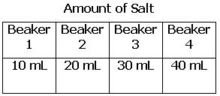
A group of students investigated the effect of salinity on the density of water. The students filled four beakers with an equal amount of water. Then they placed different amounts of salt in each beaker. Using the chart, which of the following is the best conclusion for the experiment?
- The water in beaker 1 was denser than the water in all of the other beakers.
- The water in beaker 2 was denser than the water in all of the other beakers.
- The water in beaker 3 was denser than the water in all of the other beakers.
- The water in beaker 4 was denser than the water in all of the other beakers.

A group of students counted the number of organisms observed at various depths of the ocean. What conclusion could they make about this data?
- As the depth increases, the number of organisms increases.
- As the depth decreases, the number of organisms decreases.
- As the depth increases, the number of organisms remains constant.
- As the depth decreases, the number of organisms increases.

Ocean currents are caused by changes in temperature. Which of the following statements is true?
- As the temperature of the water increases, the water will sink.
- As the water temperature decreases, the water will evaporate.
- As the temperature of the water decreases, the water will sink.
- As the temperature of the water decreases, the water will rise.

Which of the following physical characteristics allow a dolphin to camouflage itself from predators?
- White belly
- Small teeth
- Long thin nose
- Dorsal fin

An oil tanker struck an iceberg and began leaking oil into the Arctic Ocean. Which of the following will not be affected by the oil spill?
- Fish populations
- Water currents
- Shoreline conditions
- Whale feeding areas

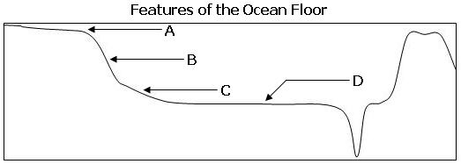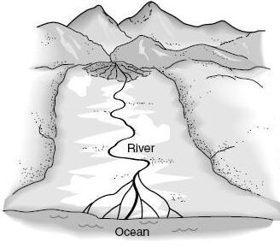

Look at the diagram above. What conclusion about salinity can be made?
A: The salinity of the ocean near the river will increase.
B: The salinity of the ocean near the river will decrease.
C: The salinity of the ocean near the river will not change.
D: The salinity of the river near the ocean will decrease.

